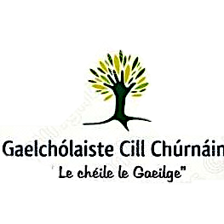
Samhradh 2018
Cursaí Samhraidh
Cúrsa A – Cill Chúrnáin, Co. Lúimní 2nd July- 6th July 2018

Cúrsa B – Gleann Dóire, Co. Ciarraí 9th July- 13th July 2018

Clár an Lae | Imeachtaí agus Spóirt
9.30-12.00 Ranganna Fóirméalta  12.00- 12.30 Céilí, Ceol, Drámaíocht  12.30-13.00 Lón  13.00-15.30 Eachtraí & Spórt –  Bronnadh na duaiseanna  sár scoláirí gach seachtain. | Each evening, after formal classes students will have the opportunity to take part in a variety of activities, and practice speaking the Irish language in a fun environment.  - Music  - Cooking classes  - Go- Karting  - Trip to Ballyhass Lakes  - Zip wiring  - Kayaking  - Swimming and gym session  - Stonehall visitor farm  - Live Céilí and Irish dance class  - Surfing in Ballybunion  - Mini Golf
Táillí/ Fees
5-11 Bliain | €130
12-15 Bliain | €160

*To secure a place on any of the courses a non-refundable deposit of €50 is required before 30th May 2016.
___________________________________________________________________________________
To apply please complete below and return to address provided:

Ainm:
Aois:
Cúrsa:
Seoladh:

Uimhir Fóin:
Eolas Breise/ Additional info:

